LeetCode_315_CountOfSmallerNumbersAfterSelf—Hard

# 题目描述

LeetCode_315_CountOfSmallerNumbersAfterSelf—Hard

难度：Hard

<https://leetcode.com/problems/count-of-smaller-numbers-after-self/description/>

You are given an integer array nums and you have to return a new counts array. The counts array has the property where counts[i] is the number of smaller elements to the right of **nums[i]**.

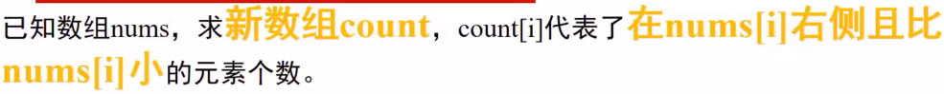

Example:

Input: [5,2,6,1]

Output: [2,1,1,0]

Explanation:

To the right of 5 there are 2 smaller elements (2 and 1).

To the right of 2 there is only 1 smaller element (1).

To the right of 6 there is 1 smaller element (1).

To the right of 1 there is 0 smaller element.

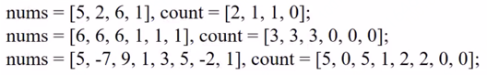

# 逆序数

解决方法1：**归并**；

解决方法2：**二叉查找树**；

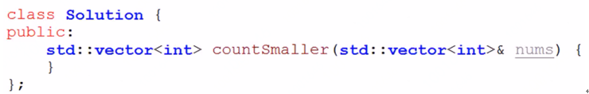

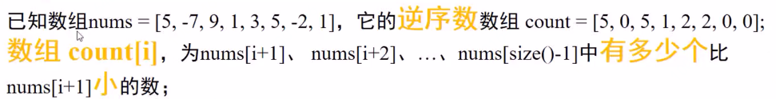

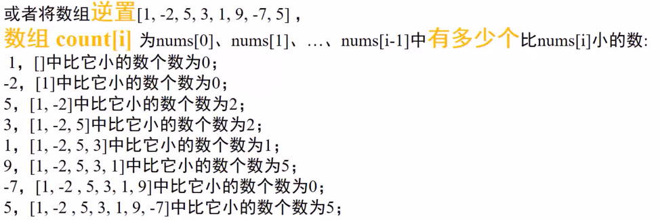



BSTNode:count用来记录左子树的节点数量。

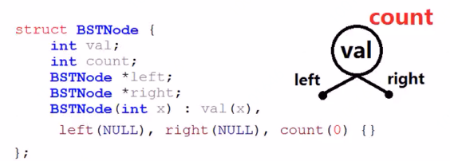

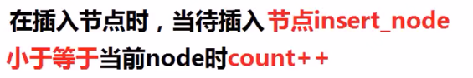

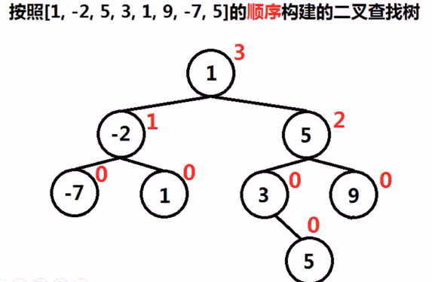



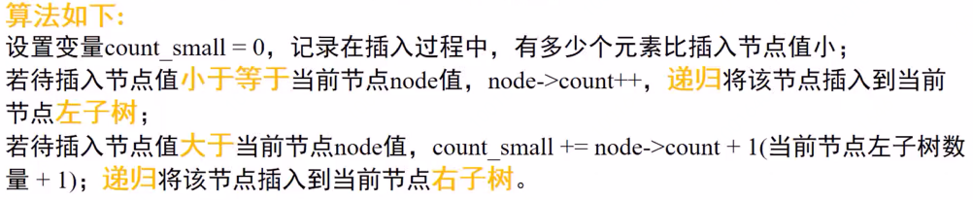

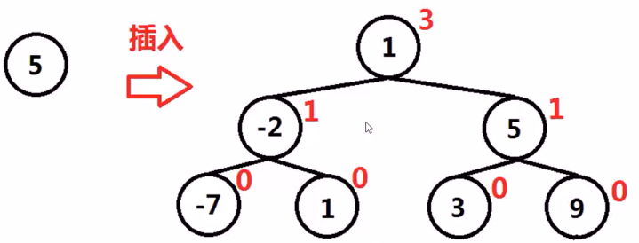

示例：

